**Oracle Administration Lab**

**Redo Log Files**

**1** List the number and location of existing log files and display the number of redo log file groups and members your database has.

**select group#,member from v$logfile ;**

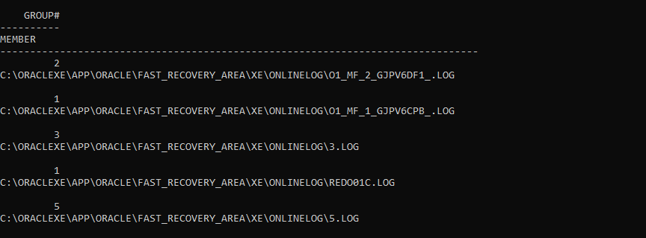

**select members from v$log;**

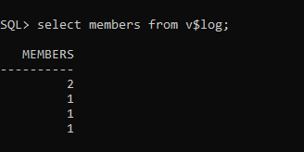

**Hints:**

- Query the dynamic view V$LOGFILE.

- Use the dynamic view V$LOG.

**2** In which database mode is your database configured? Is archiving enabled?

**Select archiver from v$instance**

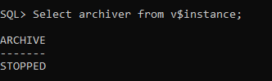

**Hints:**

- Query the dynamic view V$DATABASE.

- Query the dynamic view V$INSTANCE.

**3** Add a redo log member to each group in your database located on u04, using the following naming conventions:

**alter database add logfile member**

**'C:\ORACLEXE\APP\ORACLE\FAST_RECOVERY_AREA\XE\ONLINELOG\log01b.rdo.LOG' to GROUP 1,**

**'C:\ORACLEXE\APP\ORACLE\FAST_RECOVERY_AREA\XE\ONLINELOG\log02b.rdo.LOG' to GROUP 2**

**/**

Add member to Group 1: log01b.rdo

Add member to Group 2: log02b.rdo

Verify the result.

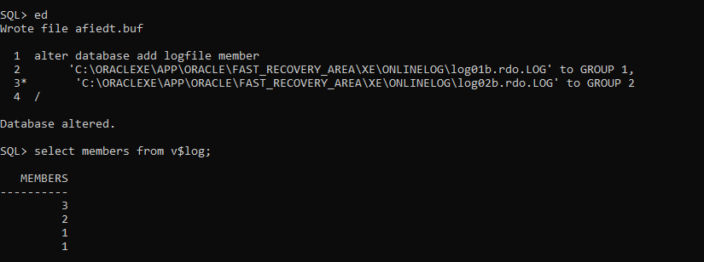

**Hints:**

- Execute the ALTER DATABASE ADD LOGFILE MEMBER command

to add a redo log member to each group.

- Query the dynamic performance view V$LOGFILE to verify the result.

**4** Add a redo log group in your database with two members located on u03 and

u04 using the following naming conventions:

Add Group 3: log03a.rdo and log03b.rdo

Verify the result.



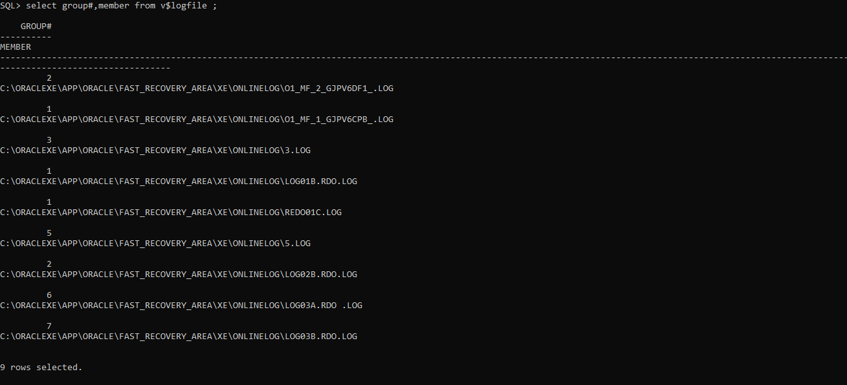

**Hints:**

- Execute the ALTER DATABASE ADD LOGFILE command to create a new group.

- Query the Dynamic View V$LOGFILE to display the name of the new members of the new group.

- Query the Dynamic View V$LOG to display the number of redo log file groups and members.

**5** Remove the redo log group created in step 4.

**alter database drop logfile group 6;**

**alter database drop logfile group 7;**

**select group#,member from v$logfile ;**

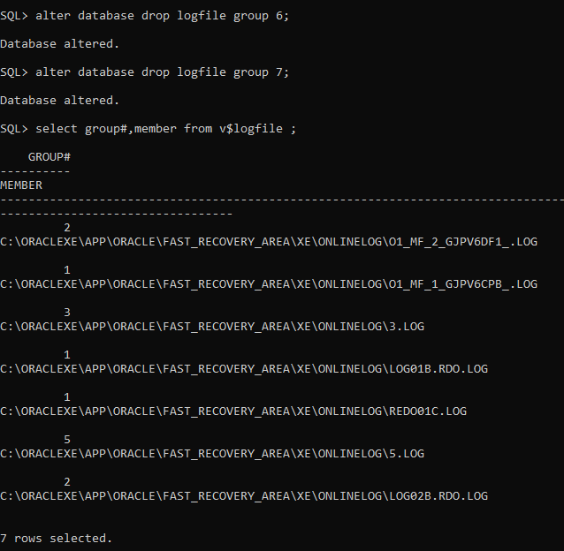

**Hints:**

- Execute the ALTER DATABASE DROP LOGFILE GROUP command to

remove the log group.

- Query the Dynamic View V$LOG to verify the result.

- Remove the operating system files for the group.

Tablespaces

Managing Tablespaces and Data Files

1 Create permanent tablespaces with the following names and storage:

a DATA01 data dictionary managed.

b DATA02 locally managed with uniform sized extents (Ensure that every used

extent size in the tablespace is a multiple of 100 KB.)

c INDX01 locally managed with uniform sized extents of 4K

( Enable automatic extension of 500 KB when more extents are required with a

maximum size of 2 MB. )

d RONLY for read-only tables with the default storage. DO NOT make the tablespace

read only at this time.

Display the information from the data dictionary.

2 Allocate 500K more disk space to tablespace DATA02. Verify the result.

3 Relocate tablespace INDX01 to subdirectory u06.

4 Create a table in tablespace RONLY. Make tablespace RONLY read-only.

Attempt to create an additional table. Drop the first created table.

What happens and why?

5 Drop tablespace RONLY and the associated datafile. Verify it.

6 Set DB_CREATE_FILE_DEST to $HOME/ORADATA/u05 in memory only.

Create tablespace DATA03 size 5M. Do not specify a file location. Verify the

creation of the data file.

RONLY u01 ronly.dbf (1 MB)

INDX01 u02 indx01.dbf (1 MB)

DATA02 u03 data02.dbf (1 MB)

DATA01 u04 data01.dbf (2 MB)

7 Allocate 500K more disk space to tablespace DATA02. Verify the result.

8 Create a table in tablespace RONLY. Make tablespace RONLY read-only.

9 Drop tablespace RONLY and the associated datafile. Verify it.